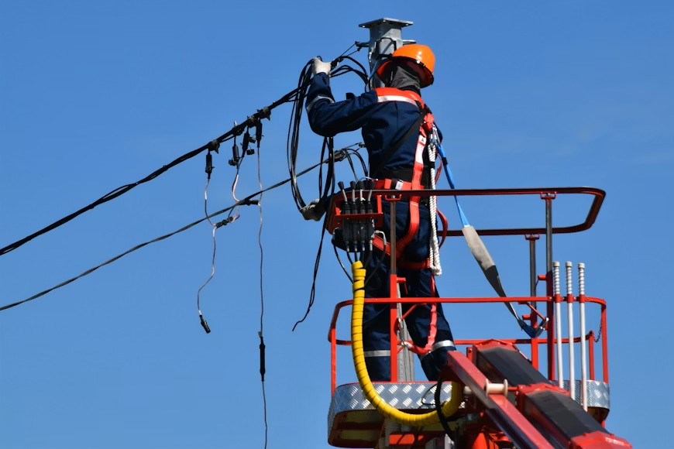
Photo by Антон Дмитриев on Unsplash

GUIDE:
Municipal COS and Tariff stakeholder engagement
March 2026

Introduction
This guide aims to support municipalities to engage stakeholders on their cost of supply and tariff application. The intention is to strengthen the electricity tariff process by:
- Building stakeholder awareness and understanding of the process
- Ensuring municipalities begin the costing and tariff process early so that there is time for meaningful stakeholder engagement.
The guide steps you through:
1. Why engage? 2
2. Improving tariff policies – template text on CoS for policy and engagement purposes 3
3. Tariffs Process Steps and Timeline 7
4. Engaging your stakeholders 8
5. Frequently Asked Questions 9

This guide has been developed in consultation with NERSA and SALGA and with funding support from UK Partnering for Accelerated Climate Transitions (UK PACT). This guide was developed based on a case study from Buffalo City and we would like to acknowledge Buffalo City officials for their time and inputs which form the backbone of this guide.




Why engage?
Engagement with stakeholders is good practice and is a legal requirement:
- Responding to public queries and challenges upfront creates goodwill and trust; it also reduces costly delays associated with litigation down the line.
- The courts have determined that COS studies must be made public
- Tariff processes require public participation (MSA/MFMA)
When Buffalo City Electricity Department published their COS study they found that very few customers engaged the detailed COS. They were interested in understanding the impact of tariff changes on their monthly bills. Developing a customer Tariff Impact Study helped address this.
The Department also found that many questions that customers put to them stemmed from misperceptions and could be addressed upfront through a “FAQs” information sheet.

Improving tariff policies – template text on CoS for policy and engagement purposes
It is important to develop or improve tariff and/or cross subsidy policies to support your tariff approaches. The following ‘template text’ provides useful background information on the legal foundation for cost of supply studies and pricing principles. This can be used in your existing tariff policy, extending your policy to include for example, cross subsidy policy approaches and during engagement on cost of supply/tariff application where customers wish to understand CoS.

Cost of supply (CoS): why, what and how – for use in Municipal tariff policy and/or stakeholder engagement

Introduction
Electricity tariffs in South Africa are guided by national laws and regulations to ensure that prices are fair, transparent, and financially sustainable. Municipal electricity distributors must follow a structured process to determine what it truly costs to supply electricity to different types of customers.
A CoS study allocates costs to different customer categories (e.g., residential, industrial) based on their consumption patterns. This aligns tariffs with the actual costs of providing electricity.
NERSA (National Energy Regulator of South Africa) oversees the CoS framework, which is guided by the Electricity Pricing Policy (EPP), promoting a balance between affordable electricity for the poor and cost-reflective tariffs. Globally, CoS studies are used in regulated markets and South Africa uses an embedded cost model similar to CoS methodologies in regulated markets in Australia and New Zealand.

The Legal Foundation
Tariff design in South Africa is guided by the Electricity Regulation Act (ERA, 2006), the Electricity Pricing Policy (2008), NERSA’s Cost of Supply (CoS) Framework (2023), and applicable municipal finance legislation.
The Electricity Regulation Act (2006) requires that electricity tariffs must:
- Allow an efficient municipality or utility to recover the full cost of supplying electricity.
- Include a reasonable margin to maintain and replace infrastructure.
- Avoid unfair discrimination between customers.
- Allow transparent cross-subsidies (for example, supporting low-income households).
The Electricity Pricing Policy (2008) translates these principles into policy positions and requires distributors to conduct regular Cost of Supply (CoS) studies. NERSA is responsible for crafting the operational rules and detailed regulatory instruments to give effect to the policy and in turn oversees and approves municipal tariffs to ensure compliance with these principles.

What Is a Cost of Supply Study?
A Cost of Supply study answers a simple question: What does it really cost to provide electricity to each customer group?
The methodology covers 4 steps.
Step 1: Revenue Requirement tells us how much money we need to collect in total.
- This includes operating costs (electricity bought from Eskom, operation and maintenance of networks), capital costs (replacing infrastructure, loan repayments) and a reasonable (regulated) return on assets.
- The CoS method allows for a regulated return on the regulated asset base, or an allowable margin on the total revenue requirement.
- Only allowable costs may be included (prudently incurred, with limits on technical and non-technical losses).
Step 2: Cost Categorization asks what is the source of the cost? And splits costs into the essential value chain elements.
- Generation costs: producing the electricity
- Transmission costs: moving electricity across long distances
- Distribution costs: getting electricity to homes
- Customer service costs: billing, customer support
Step 3: Cost Classification sorts costs into fixed (unchanging) and variable (changing with usage).
This depends on the type of cost – and what drives the cost:
- Energy-related costs – based on how much electricity (kWh) is used. Variable.
- Demand-related costs – based on network costs such as cables, transformers, substations based on peak usage (kVA). Fixed and sometimes ‘fixed variable’.
- Customer-related costs: billing, metering and administration. Fixed.
Step 4: Cost Allocation ensures that each customer pays a fair share of the costs based on their usage.
Costs are allocated to different customer categories such as residential, business, industrial and agricultural customers. This step determines the cost to serve each group based on:
- Energy units consumed; for larger customers it is also based on the time of use.
- Demand: based on the size of customer connections and the how much usage coincides with the peak demand on the grid (driving the size of networks and power stations required for reliability).
- How much service they receive: metering, billing and other service requirements of a customer group.

Tariff Design
Once the cost per customer category is known, and the building blocks of the fixed and variable costs have been determined, tariffs are designed to recover those costs through:
- Energy charges (R/kWh).
- Demand charges (R/kVA).
- Fixed monthly charges.
Cost reflective tariff design helps to ensure that the revenue required can be raised. However, they must also address the principles of equity and affordability, and this is why tariff design is often called an art, rather than a science. Municipalities may phase in required price increases gradually for affordability reasons, but long-term financial sustainability remains essential.

Why This Matters
Electricity infrastructure is expensive to maintain and replace. If tariffs are too low, municipalities cannot properly maintain networks, which may lead to more outages, declining service quality, and financial instability.
The Cost of Supply process helps ensure fair pricing, transparency, financial sustainability, continued investment in infrastructure, and structured support for low-income households.
In simple terms, the Cost of Supply process ensures that electricity prices reflect the real cost of delivering power — fairly, transparently, and in a way that keeps the lights on for everyone.

The Nersa-endorsed Cost of Supply Model
The NERSA endorsed Cost of Supply (COS) model developed under the SAGEN programme is an Excel-based analytical tool designed to enable South African municipalities to undertake structured, defensible cost-of-service studies and to support tariff submissions to NERSA. The model reflects the NERSA COS methodology and includes future costing study direction capabilities.
Its core purpose is to determine a municipality’s revenue requirement and allocate that requirement to customer categories in a transparent and cost-reflective manner, in line with a globally accepted method based on engineering principles.
At a high level, the model integrates technical, financial and commercial data across multiple years. It captures historical (Year 0), current (Year 1) and forecast (Years 2–4) information, allowing municipalities to compute tariffs for the upcoming financial year within a multi-year framework. Users first define methodological choices – such as the adopted revenue requirement approach (e.g. return on regulated asset base or a risk adjusted margin, or ‘surplus’ on OPEX), treatment of depreciation, asset valuation timing (BOY/EOY/mid-year), loss capping, and forecasting methods for sales and OPEX. These decisions shape how costs are calculated and allocated.
The model then consolidates detailed inputs, including asset register values by voltage level, Eskom and non-Eskom power purchase volumes and costs, OPEX by function, depreciation, customer numbers, sales (kWh), demand (kVA), technical and non-technical losses, and load characteristics. Costs are classified into energy-driven, demand-driven and customer-driven components, and allocated between wires and retail business areas. This enables cost-to-serve (CTS) calculations for each customer category.
Beyond calculating the revenue requirement, the model supports tariff design and impact analysis. It includes dashboards for reviewing COS results, tools for designing end-user rates, and functionality to test rate impacts across customer groups. A data quality diagnostic feature further ensures completeness and consistency of inputs before results are interpreted.
In essence, the COS model provides a structured, standardised methodology for municipalities to quantify their true cost of service, improve cost reflectivity, and strengthen the financial sustainability and regulatory credibility of their electricity tariffs.
For further information on cost of supply
PARI (2025): Comparative review of global approaches to electricity tariff setting by Shirley Salvoldi
Video introduction to COS in South Africa.

Tariffs Process Steps and Timeline
* Internal stakeholders (CFO, Municipal Manager, Portfolio Committee) and external (major customer group reps)
** Requires the following documentation: (1) updated CoS, (2) tariff impact analysis and, (3) evidence of stakeholder engagement: council resolution and notice of CoS and draft Tariff schedule to customers for engagement.

Engaging your stakeholders
Tariffs are a complex process. Engagement must factor this in.
Step 1: Early engagement: Publish your draft tariff application and notify customers that the associated documents are available on request
- Publish your Draft Tariff Application on your municipal website (it is easy to PDF this).
- Most customers won’t engage COS but are interested in the outcome – the tariff impact on them. A customer impact analysis will support them to establish this. Do this study and PDF the high level outcomes alongside the Tariff Application.
- Email all customers to inform them that they may request an Excel copy of the COS study and Tariff Impact analysis directly from the Municipality. Publishing the Xcel based CoS study and Tariff Impact Analysis on the municipal website may not be possible as the Excel format may not be compatible with IT requirements for web publication.
- Draw on, or share, the CoS template text to explain to customers what CoS and tariff setting is about (provided in this Guide).
- Also include FAQ’s and responses to answer some concerns upfront (provided in this Guide).
Step 2: Create an open communication channel through the entire process
- Proactively reach out to customers, e.g. mass emails to all and send personalised communication to key customers (e.g. Chamber of Commerce).
- Create an open communication channel through email, one-on-one meetings and public participation, e.g. IDP Roadshow.
- Make it clear that the Municipality is open to constructive feedback and demonstrate, where possible, that you are addressing concerns.
- Provide (global and local) tariff benchmarks.
- Share FAQs / responses to common tariff misperceptions. Some examples you can draw on are provided in the guide.
In Buffalo City stakeholder engagement resulted in people requesting a social housing tariff; business complexes noted they cannot recover the KVA –fixed- charge when they on-sell to customers in terms of the Resellers policy. They can charge it via the variable kWh charge on a pro rata basis. Buffalo City responded to this feedback with new tariff innovations and will introduce a flat kWh rate for business complex customers, i.e. “pro rata” fixed costs included upfront.

Frequently Asked Questions
Customer concerns around tariffs can be pre-empted by creating awareness through providing information upfront on FAQs. Some common questions and answers are provided for use below.
What am I paying for?
Your electricity tariff covers:
- The electricity (kWh) you actually use.
- Capacity (power on demand): You pay to have electricity available instantly, whenever you need it — even if you only use it occasionally. This includes power stations, wires, substations, and transformers.
- Service costs: Metering, billing, customer support, and system management.
Why is my business tariff different to other municipalities or Eskom?
Not all electricity systems cost the same to run. Tariffs reflect local realities. Costs differ due to:
- Geography: e.g. grids may cost more to run in a hilly terrain.
- Network size and age: Older or more spread-out networks cost more to maintain.
- Customer mix: Municipalities with many small residential users must recover costs differently to those with large industrial customers.
However, work is underway to make sector tariffs more standardised.
[It might be useful to demonstrate your tariff against those in similar municipal types; and globally].
Why must I pay a fixed charge if I have solar and hardly use the grid?
Because the grid still has to be there for you — instantly. Even with solar:
- You rely on the grid at night, during bad weather, or when your system trips.
- The network must be sized and maintained to meet your maximum possible demand, not just your average use.
If these costs weren’t recovered through fixed charges, they would be shifted onto other customers — which is unfair.
The municipality does welcome your SSEG investment and you are credited Rxxx per unit for energy you export, but availability still has a cost.

Is the new fixed (basic) charge making my bill more expensive?
Not necessarily — it’s mostly a change in how costs are charged.
What’s changed:
- These fixed costs already existed.
- They were previously recovered through unit (kWh) charges.
- Now they are shown explicitly as a fixed charge, and unit prices are reduced.
Why this matters:
- It reflects the real cost of supplying electricity.
- It protects the grid as sales decline (e.g. due to solar and efficiency).
- It improves long-term reliability for everyone.
This makes the system more stable (it can cover the cost required to keep the service going) and fair — not more expensive.
I know that municipal electricity losses are high; why must I pay for these?
You’re not paying for unlimited losses. There are two types of losses:
- Technical losses: Normal energy losses when electricity flows through wires and transformers.
- Non-technical losses: Electricity that is stolen, unmetered, or incorrectly billed.
Regulation strictly limits how much loss can be included in tariffs.
Only up to 12% of total losses is allowed. Any losses above that must be paid by the Municipality, not customers.
Losses are a serious challenge — but only a reasonable, regulated amount is reflected in your tariff.

Why is my tariff higher than what it costs to serve me? Or Why must I pay for other people’s electricity?
Because electricity systems work on shared costs — everywhere in the world and it is common for policy to ensure that all citizens are included in the benefits of the grid (Electricity Pricing Policy, 200). This is called cross-subsidy, and it happens:
- Within customer groups: High users pay slightly more; low users pay slightly less.
- Between groups: Commercial, industrial and higher-income customers help ensure poorer households can afford electricity.
Why this works:
- It is simpler to group customers with simpler patterns of usage than have a separate tariff for each and every customer.
- Everyone benefits from a connected society: It supports health, education, safety, and economic participation.
- It’s ultimately cheaper to include more customers – more people contribute something to meet the system costs, meaning costs are lower overall.
Municipal Cost of Supply (CoS) studies will help to ensure these subsidies are transparent, fair and economically sound. This is how we sustain a grid for all, without over-burdening any one group.

